**What is a Binary Tree?**

Before we proceed to learn what binary trees are, we’ll give ourselves a quick revision of what we learned in the previous lecture.

1. A tree is made up of nodes and edges.
2. The topmost node is called the Any node which points to another node, is the **parent** of that node and the node which the parent is pointing at is the **child**of that parent node. And nodes having the same parents are called **siblings** of each other.
3. Nodes having zero children are the**leaf nodes or the external nodes**, and nodes having at least one child are the**internal nodes**.
4. **Ancestors** of a node are the nodes accessible by traversing upwards along the edges. They are either the parents or the parents of the parents.
5. **Descendants** of a node are the nodes accessible by traversing downwards along the edges. They are either the children or the children of the children.
6. **Height** of a node is the number of edges in between the deepest leaf and that node. And **depth** of a node is the number of edges between the root and that node.

Apart from these, there are a few additional points that I would like to add.

1. A tree with**n** nodes has **n-1** Why n-1?

Because in a tree, there is one and only edge corresponding to all the nodes except the root node. The root node has no parent, hence no edge pointing to it. Therefore, a total of n-1 edges.

1. The **degree of a node** in a tree is the number of children of a node.
2. The **degree of a tree** is the highest degree of a node among all the nodes present in the tree.

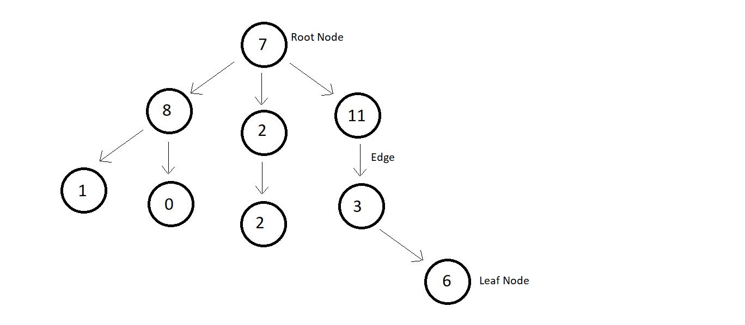

In the above tree, the number of nodes is 9, and hence the number of edges are 8. You can even count and verify the fact that a tree with n nodes has n-1 edges. Moreover, the highest degree of a node is that of the root node, which has 3 children. Hence the degree of the tree is also 3.

Binary Tree

A binary tree is a special type of tree where each node has a degree equal to or less than two which means each node should have at most two children.

Few examples of a binary tree are mentioned below:

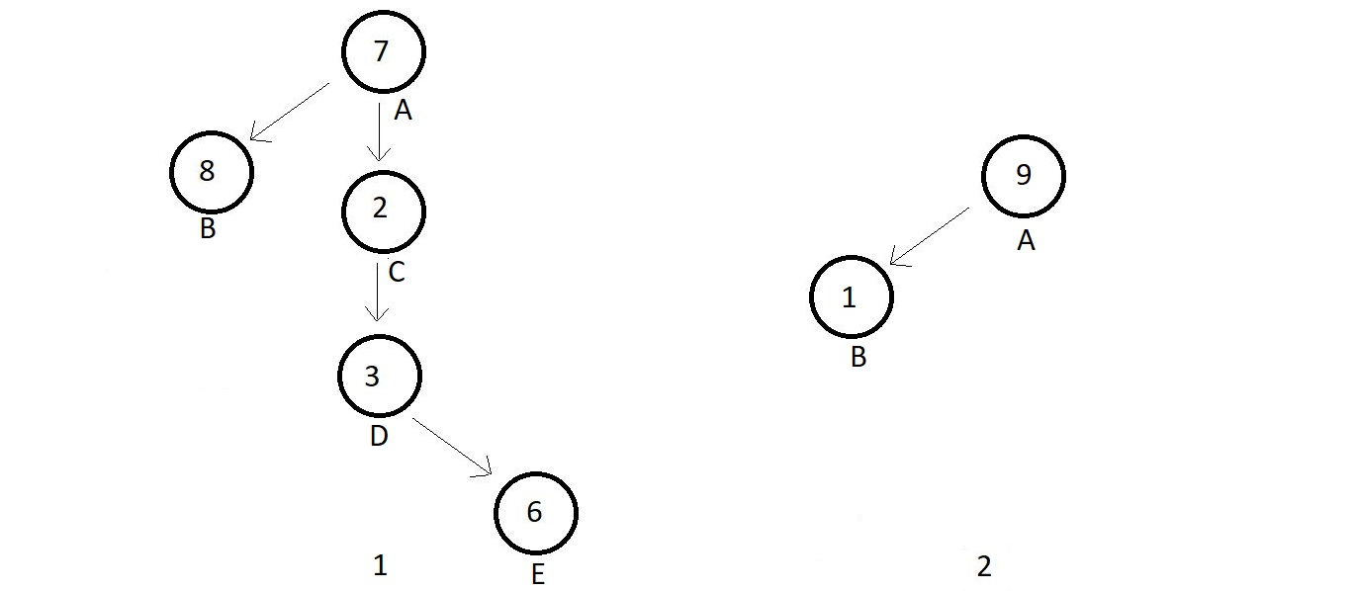

Example 1 has nodes A, B, C, D, E with degrees {2, 0, 1, 1, 0} respectively which satisfies the conditions for a binary tree. Similarly, example 2 has nodes A and B, having degrees 1 each, hence a binary tree